The only point of no return is … when we’re dead!

Interview with Benito Müller, ecbi Director, on TRT World, an Istanbul-based English speaking international news channel on the occasion of the Global Climate Strike 20 September 2019.

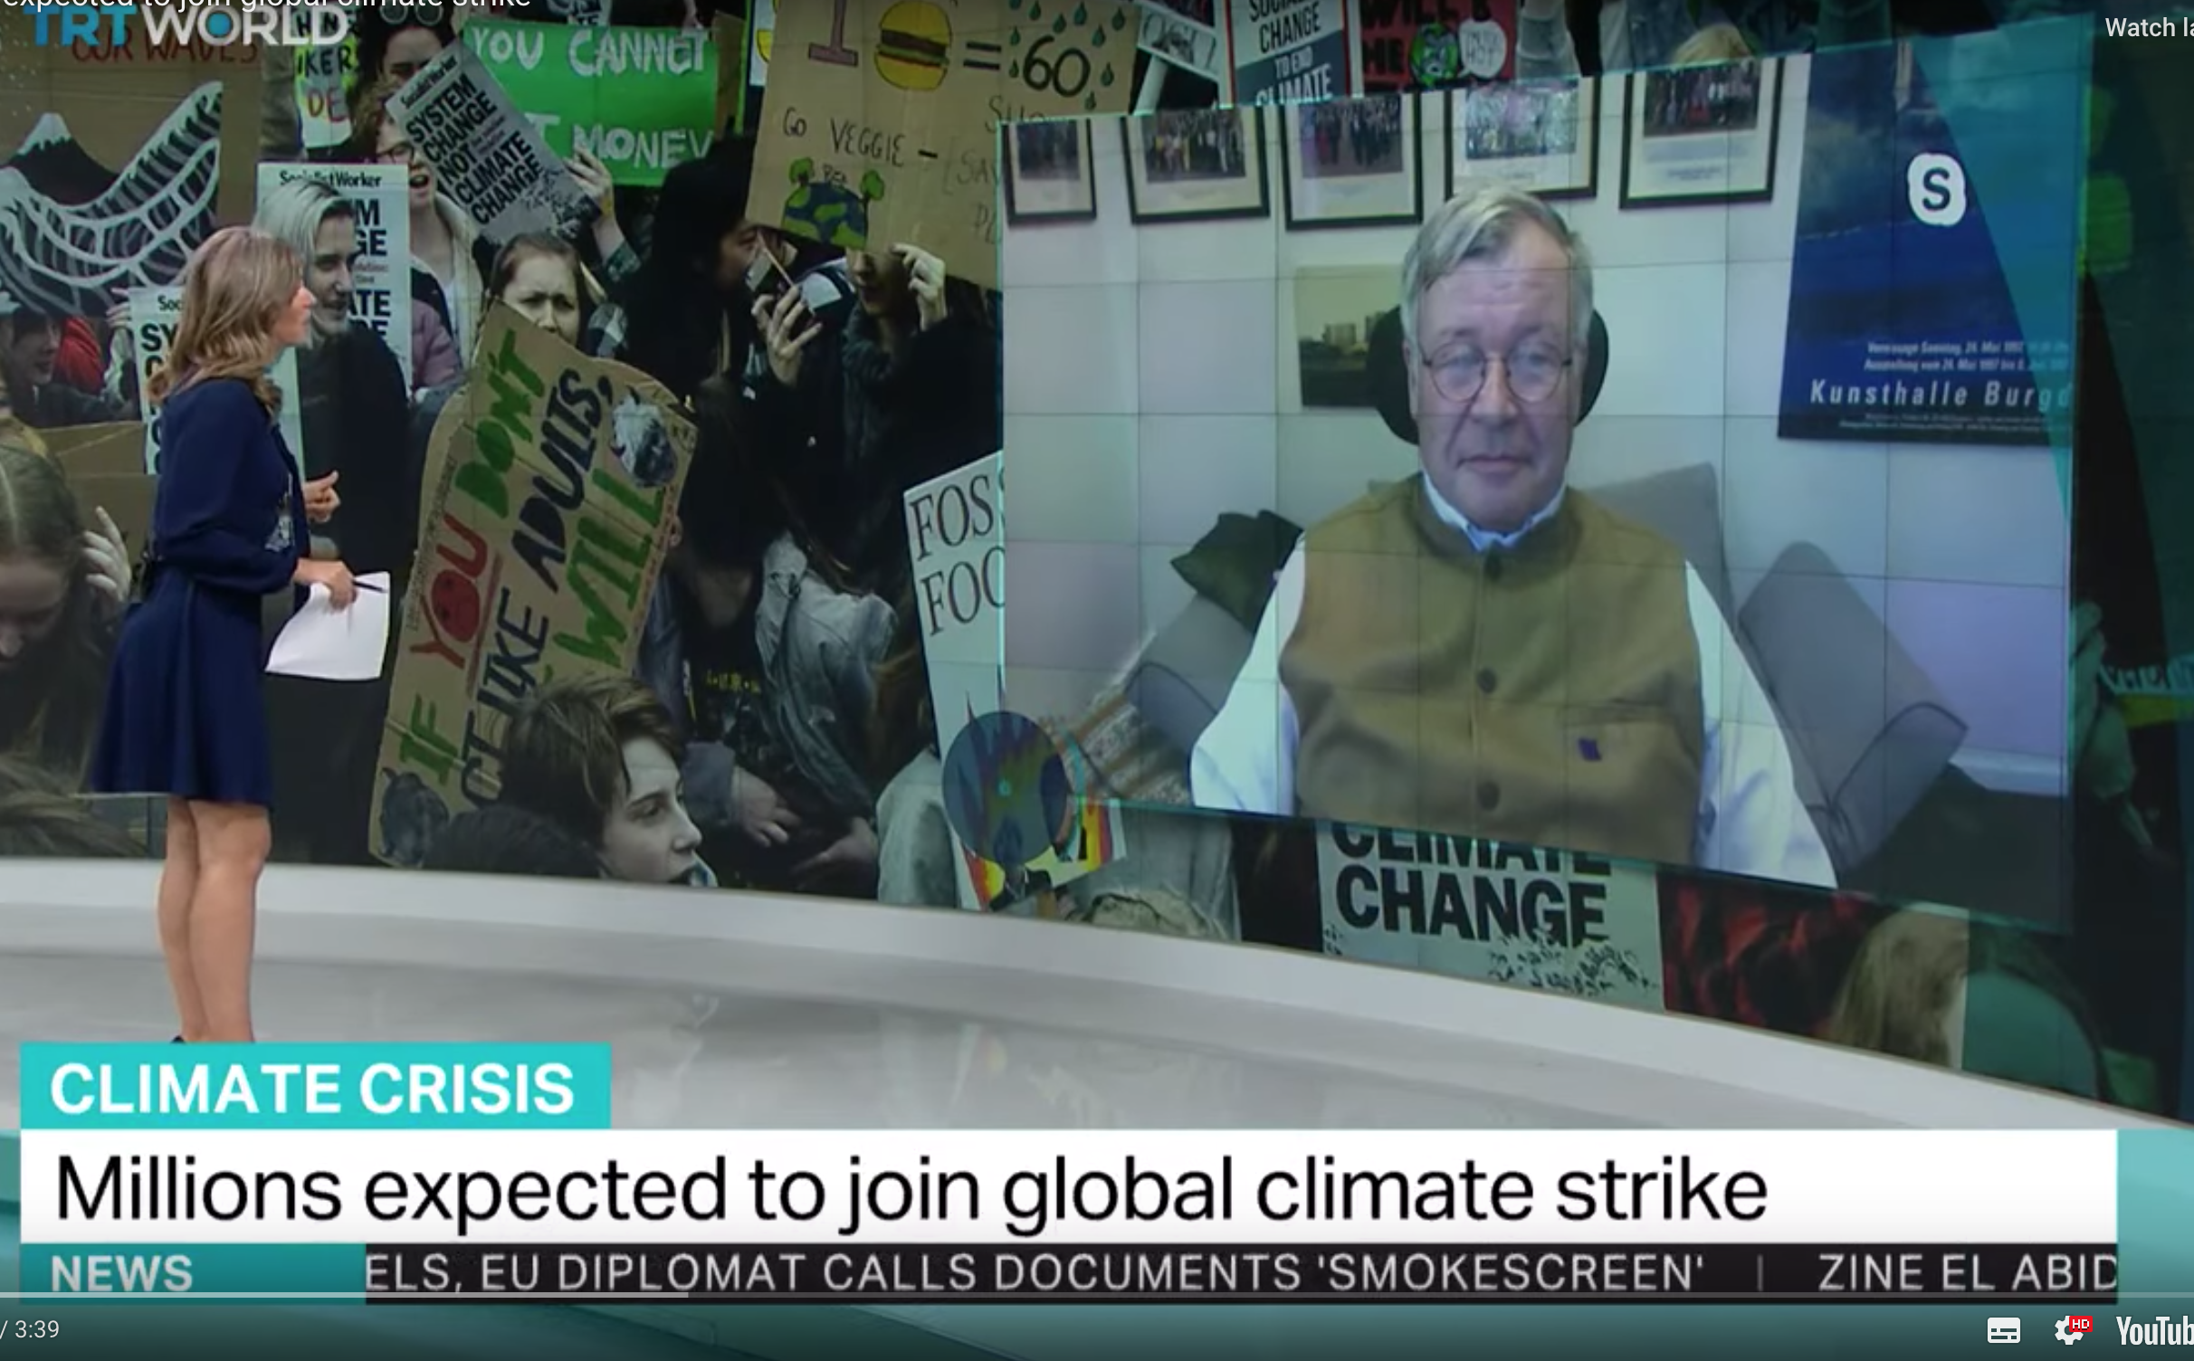

Transcript

Question. “How encouraged are you by what you’re seeing today – are these voices really being heard?”

Müller: “Good afternoon. Yes, I think they are being heard, and particularly if the movement perseveres.”

Question. “Okay, so they still need to go forward. The problem, for many, is challenging the actual leaders, their response to this. Many of them say this movement is about uppity youth who really don’t actually understand the world itself and the economics of what they’re demanding – so what do you say to them?”

Müller: “I think it is funny how popular opinion is rejected by politicians on grounds that the people are ignorant, if they don't like what is being said - and if they like the message, it is the will of the people! So, I’m not too worried about the situation that the politicians who don’t like the message about climate change criticize the youth for not being knowledgeable enough.”

Question. “But it is a problem because when we have leaders in some of the most powerful and populous countries in the world being elected on the grounds that they don’t buy into climate change, what do you do? What action can really be taken then to curb what you see as something that can doom all of us?”

Müller: “The voices of these young people will be heard for two reasons. First of all, many of them have the vote, or will have it soon, or will influence their families. And what ultimately counts for a politician is: VOTES. So, if we influence them by showing them that what they’re doing will lose them votes, they will change their mind.

Also, they are also a major consumer segment, and you’d be surprised how quickly the private sector reacts if the consumers change their mind of what to buy. And then, we have a change in attitude - this movement of consumers and voters will have to be much more vocal about what this issue is about, and not wait for politicians to force us to do something.”

“Okay, let me speak to your policy expertise; where do we actually stand as far as preventing global warming is concerned? Some say we passed the point of no return, other think the right policy could throw this all into reverse – where do you stand?”

Müller: “We may have passed the point of avoiding all adverse impacts – we certainly have, but as far as I’m concerned there is only one point of no return in this game for each one of us: when we're dead! Until then we have to persevere!

We have to do as much as possible to minimize the damage – damage will be done, there’s no doubt about it, but we still can try to reduce what is going to happen. And young people will be much more exposed than the people of my generation, that’s why they should take an interest in this.”

